# Python Variables

Variable is a name of the memory location where data is stored. Once a variable is stored that means a space is allocated in memory.

## Assigning values to Variable:

We need not to declare explicitly variable in Python. When we assign any value to the variable that variable is declared automatically.

The assignment is done using the equal (=) operator.

**Eg:**

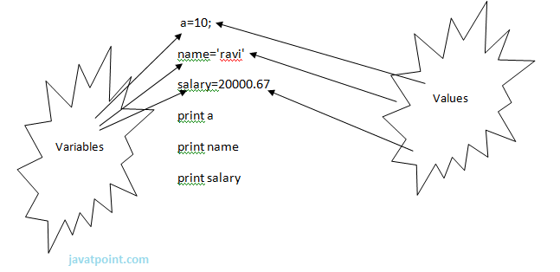

**Output:**

1. >>>
2. 10
3. ravi
4. 20000.67
5. >>>

## Multiple Assignment:

Multiple assignment can be done in Python at a time.

There are two ways to assign values in Python:

**1. Assigning single value to multiple variables:**

**Eg:**

1. x=y=z=50
2. print x
3. print y
4. print z

**Output:**

1. >>>
2. 50
3. 50
4. 50
5. >>>

**2.Assigning multiple values to multiple variables:**

**Eg:**

1. a,b,c=5,10,15
2. print a
3. print b
4. print c

**Output:**

1. >>>
2. 5
3. 10
4. 15
5. >>>

The values will be assigned in the order in which variables appears.

### Basic Fundamentals:

This section contains the basic fundamentals of Python like :

**i)Tokens and their types.**

**ii) Comments**

**a)Tokens:**

* Tokens can be defined as a punctuator mark, reserved words and each individual word in a statement.
* Token is the smallest unit inside the given program.

There are following tokens in Python:

* Keywords.
* Identifiers.
* Literals.
* Operators.

### Tuples:

* Tuple is another form of collection where different type of data can be stored.
* It is similar to list where data is separated by commas. Only the difference is that list uses square bracket and tuple uses parenthesis.
* Tuples are enclosed in parenthesis and cannot be changed.

**Eg:**

1. >>> tuple=('rahul',100,60.4,'deepak')
2. >>> tuple1=('sanjay',10)
3. >>> tuple
4. ('rahul', 100, 60.4, 'deepak')
5. >>> tuple[2:]
6. (60.4, 'deepak')
7. >>> tuple1[0]
8. 'sanjay'
9. >>> tuple+tuple1
10. ('rahul', 100, 60.4, 'deepak', 'sanjay', 10)
11. >>>

### Dictionary:

* Dictionary is a collection which works on a key-value pair.
* It works like an associated array where no two keys can be same.
* Dictionaries are enclosed by curly braces ({}) and values can be retrieved by square bracket([]).

**Eg:**

1. >>> dictionary={'name':'charlie','id':100,'dept':'it'}
2. >>> dictionary
3. {'dept': 'it', 'name': 'charlie', 'id': 100}
4. >>> dictionary.keys()
5. ['dept', 'name', 'id']
6. >>> dictionary.values()
7. ['it', 'charlie', 100]
8. >>>